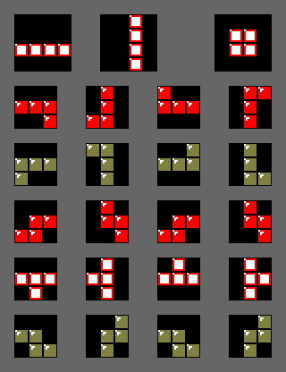Shown above is the rotation diagram for the NES Tetris Version. It uses Nintendo’s right hand rotation rule for tetrominoes.

|  |  |  |  |
| --- | --- | --- | --- |
| 1 line | 2 lines | 3 lines | 4 lines |
| 40*(n+1) | 100*(n+1) | 300*(n+1) | 1200*(n+1) |

Scoring is done using the formulas above, for one line the number of points is listed in the table below, where n is the current level (starting at level 0)

|  |  |  |
| --- | --- | --- |
| Level | Frames | Time (ms) |
| 0 | 48 | 798.68 |
| 1 | 43 | 715.49 |
| 2 | 38 | 632.29 |
| 3 | 33 | 549.10 |
| 4 | 28 | 465.90 |
| 5 | 23 | 382.70 |
| 6 | 18 | 299.51 |
| 7 | 13 | 216.31 |
| 8 | 8 | 133.11 |
| 9 | 6 | 99.84 |
| 10-12 | 5 | 83.20 |
| 13-15 | 4 | 66.56 |
| 16-18 | 3 | 49.92 |
| 19-28 | 2 | 33.28 |
| 29+ | 1 | 16.64 |

The time between block movements is listed in the table above per level, based on the NES standard framerate of 60.0988 frames/sec